January  Little Disciples | 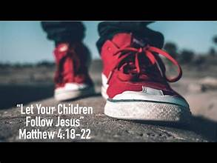
Sunday | Monday | Tuesday | Wednesday | Thursday | Friday | Saturday
 | 1 | 2 | 3 | 4 | 5 | 6
 |  |  | Families 5:45-6:45  God’s covenant with Abraham  Kids with leaders-Abraham |  |  | Epiphany Blessing- bless your home
7 | 8 | 9 | 10 | 11 | 12 | 13
Parents at home:
Read story of the Magi watch video

14 | 15 | 16 | 17 | 18 | 19 | 20
Faith Fun Night
5:45-6:45
Baby Jesus Birthday party
21 | 22 | 23 | 24 | 25 | 26 | 27
Parents at home:
Star craft
God’s story video
28 | 29 | 30 | 31
Families 5:45-6:45
God’s covenant with Moses
Kids with Leaders Moses

