September
Little Disciples
Sunday | Monday | Tuesday | Wednesday | Thursday | Friday | Saturday
 |  |  | August 30 |  | September 1 | 2
Families 5:45-6:45
Bingo Sign up night

Sloppy joes & tator tots
3 | 4 | 5 | 6 | 7 | 8 | 9
 | Labor day |  | Families 5:45-6:45  Parents & kids bring Bibles  Kids The Bible intro with leaders
10 | 11 | 12 | 13 | 14 | 15 | 16
Parents at home:
Practice Prayers, set up prayer space & email pic, watch videos, talk about & begin family tree
17 | 18 | 19 | 20 | 21 | 22 | 23
Faith Fun Night 5:45-6:45
Bible games
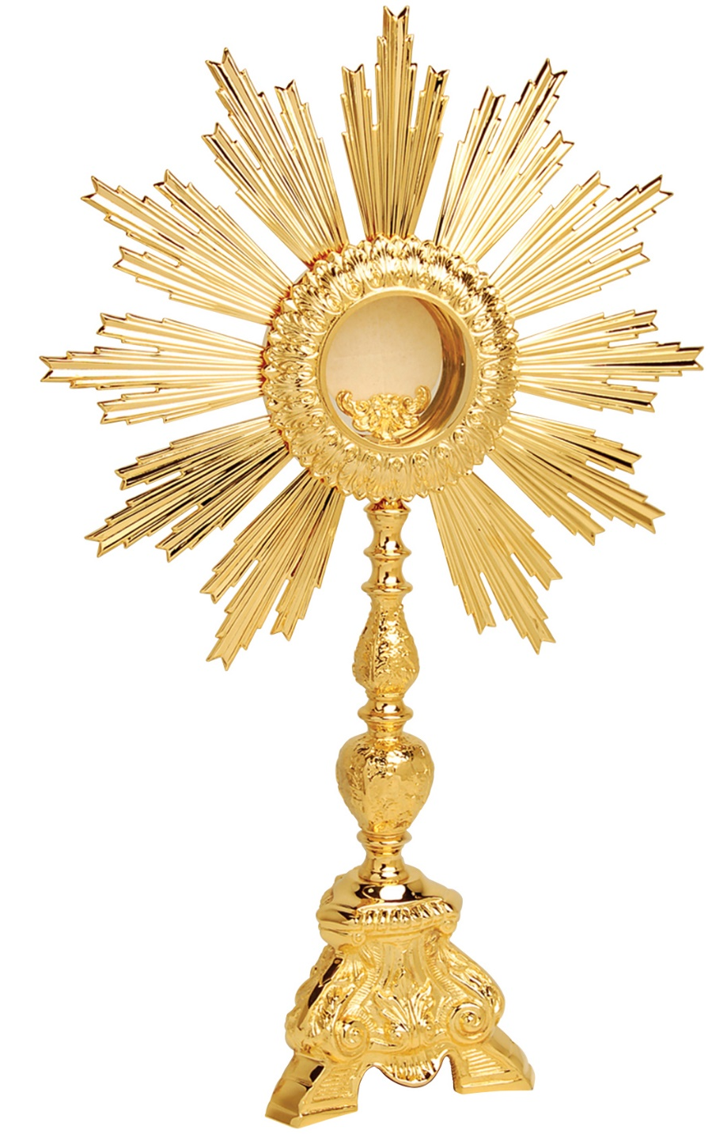  24 | 25 | 26 | 27 | 28 | 29 | 30
Adoration  Priesthood  Sunday |  |  | Parents at home:  Family tree, M & M game, Read Creation story with kids
ctober
Little Disciples
Sunday | Monday | Tuesday | Wednesday | Thursday | Friday | Saturday
1 | 2 | 3 | 4 | 5 | 6 | 7
Families 5:45-6:45
Parents :
Kahoot & Creation
Kids: Creation with leaders

8 | 9 | 10 | 11 | 12 | 13 | 14
 | Columbus Day |  | Parents at home:  Home alter/prayer wall pic of loved one, talk about saints, pray for you loved one/rosary
15 | 16 | 17 | 18 | 19 | 20 | 21
Faith Fun Night 5:45-6:45
Glow rosary
22 | 23 | 24 | 25 | 26 | 27 | 28
Parents at home:
Review Creation story & Adam & Eve-creation wheel, responsibility for creation- go on creation scavenger hunt
29 | 30 | 31
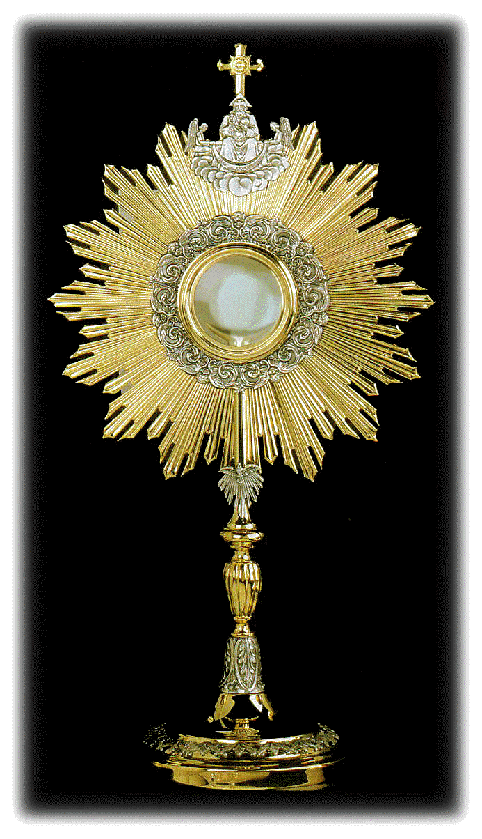

November
Little Disciples
Sunday | Monday | Tuesday | Wednesday | Thursday | Friday | Saturday
 |  |  | 1 | 2 | 3 | 4
Families: short meeting after mass
Parents at home: week 1 read Bible story Adam & Eve
No Little Disciples

5 | 6 | 7 | 8 | 9 | 10 | 11
Parents at home:
week 2
Works of Mercy-Box of Joy send off
Advent Activities
12 | 13 | 14 | 15 | 16 | 17 | 18
Faith Fun Night 5:45-6:45

practice
Children’s skit/play
19 | 20 | 21 | 22 | 23 | 24 | 25
Parents at home: week 3
Rosary(Joyful) or prayers
Jesse Tree
26 | 27 | 28 | 29 | 30
Advent Night
5:45
Prayer, dinner, activity & children’s skit/play

December  Little Disciples | 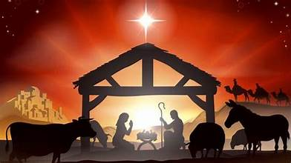
Sunday | Monday | Tuesday | Wednesday | Thursday | Friday | Saturday
 |  |  |  |  | 1 | 2
3 | 4 | 5 | 6 | 7 | 8 | 9
Families 5:45-6:45
Covenants & Sacraments
kids with Leaders-
Noah’s Ark

10 | 11 | 12 | 13 | 14 | 15 | 16
 |  |  | Faith Fun Night | Parents at home:  Review Noah’s Ark  God’s covenant with man kind  Watch 3 videos
17 | 18 | 19 | 20 | 21 | 22 | 23
Parents at home
God is Faithful rainbow
24 | 25 | 26 | 27 | 28 | 29 | 30
 |  |  | :

January
Little Disciples
Sunday | Monday | Tuesday | Wednesday | Thursday | Friday | Saturday
 | 1 | 2 | 3 | 4 | 5 | 6
 |  |  | Families 5:45-6:45  God’s covenant with Abraham  Kids with leaders-Abraham |  |  | Epiphany Blessing- bless your home
7 | 8 | 9 | 10 | 11 | 12 | 13
Parents at home:
Read story of the Magi watch video

14 | 15 | 16 | 17 | 18 | 19 | 20
Faith Fun Night
5:45-6:45

21 | 22 | 23 | 24 | 25 | 26 | 27
Parents at home:
Star craft
God’s story video
28 | 29 | 30 | 31
Families 5:45-6:45
God’s covenant with Moses
Kids with Leaders Moses

February
Little Disciples
Sunday | Monday | Tuesday | Wednesday | Thursday | Friday | Saturday
 |  |  |  | 1 | 2 | 3
4 | 5 | 6 | 7 | 8 | 9 | 10
 |  |  | Lent Night
11 | 12 | 13 | 14 | 15 | 16 | 17
 |  |  | Parents at home:
18 | 19 | 20 | 21 | 22 | 23 | 24
 |  |  | Faith Fun Night 5:45-6:45
25 | 26 | 27 | 28 | 29
 |  |  | Parents at home:

March
Little Disciples
Sunday | Monday | Tuesday | Wednesday | Thursday | Friday | Saturday
 |  |  |  |  | 1 | 2
3 | 4 | 5 | 6 | 7 | 8 | 9
Families 5:45-6:45
Jesus the new Moses
10 | 11 | 12 | 13 | 14 | 15 | 16
 |  |  | Parents at home:
17 | 18 | 19 | 20 | 21 | 22 | 23
 |  |  | Faith Fun Night 5:45-6:45
24 | 25 | 26 | 27 | 28 | 29 | 30
 |  |  | Parents at home: |  | LD Stations of the cross

April
Little Disciples
Sunday | Monday | Tuesday | Wednesday | Thursday | Friday | Saturday
March 31 | 1 | 2 | 3 | 4 | 5 | 6
Families 5:45-6:45
Parents
Kids

7 | 8 | 9 | 10 | 1`1 | 12 | 13
 |  |  | Parents at home:
14 | 15 | 16 | 17 | 18 | 19 | 20
 |  |  | Faith Fun Night 5:45-6:45
21 | 22 | 23 | 24 | 25 | 26 | 27
 |  |  | Parents at home:
28 | 29 | 30

May
Little Disciples
Sunday | Monday | Tuesday | Wednesday | Thursday | Friday | Saturday
 |  |  | 1 | 2 | 3 | 4
Families 5:45-6:45
Parents:

Kids with leaders

5 | 6 | 7 | 8 | 9 | 10 | 11
12 | 13 | 14 | 15 | 16 | 17 | 18
19 | 20 | 21 | 22 | 23 | 24 | 25
26 | 27 | 28 | 29 | 30 | 31

