SPONSOR FORM
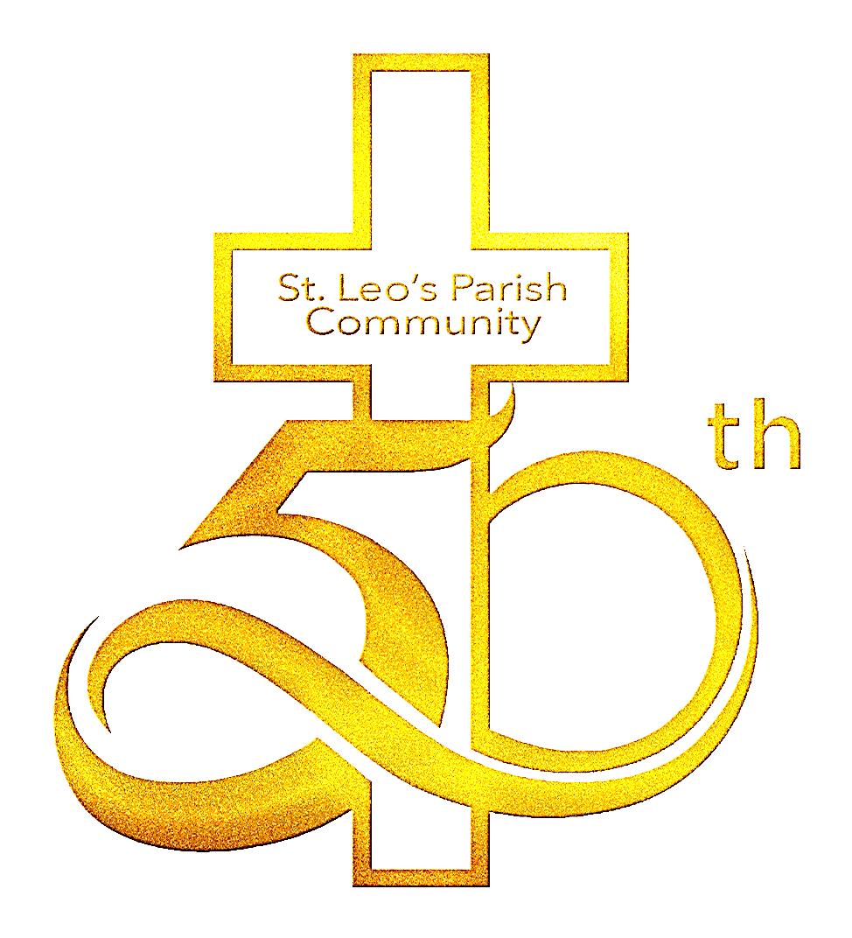
St Leo’s Catholic Church 50th Anniversary Scramble
Sunday June 4th (12PM Check-in, 1PM Shotgun Start)
Indianhead Golf Club, Grand Island, NE

Come celebrate the 50th Anniversary of our wonderful St. Leo’s Catholic Church with a day on the links! This event is being held to recognize the glory of Christ’s work in the founding of an institution that has blessed our families and our community for 50 years! Thank you for supporting your parish by either fielding a team, by sponsoring the food, beverages, a hole, or by volunteering to help! Proceeds will go to offset the costs of the event and to hopefully raise a little bit of money for St. Leo’s. Price per 4-Person team will be $400, which includes golf, cart, prizes, dinner and 2 drink tickets per player (Mulligans may be purchased at registration). Sponsorship options are as follows:

Platinum Sponsorship
Either full Food or Beverage Sponsorship = $1,500-$2,500
Includes signage and one team of 4 players
Gold Sponsorship
Includes Hole Sponsorship sign and one team of 4 players = $500
Silver (Hole) Sponsorship
Includes a hole sign on the tee box of a hole = $150

Player #1 _______________________________ GHIN Hdcp____ Avg 9H score if no GHIN____
Cell# ____-____-________

Player #2 _______________________________ GHIN Hdcp____ Avg 9H score if no GHIN____
Cell# ____-____-________

Player #3 _______________________________ GHIN Hdcp____ Avg 9H score if no GHIN____
Cell# ____-____-________

Player #4 _______________________________ GHIN Hdcp____ Avg 9H score if no GHIN____
Cell# ____-____-________

YES!!! I would like to be a Platinum / Gold / Silver Sponsor. (Please circle one or more)
Please make checks payable to St. Leo's Catholic Church, or you may pay by Visa/Mastercard below.

Visa/MC (circle) Acct#_______________________________________; Exp. Date:__________ Zip Code_________

Name on Card_________________________________________________ 3-Digit Security Code _______
PLEASE SEND YOUR SPONSOR FORM TO: AND  Father Don Buhrman  c/o St.Leo's Catholic Church  2410 S. Blaine St, Grand Island, NE 68801 | EMAIL YOUR COMPLETED ENTRY TO:  mkwmcfarland@yahoo.com  If you do not receive a confirmation email within 48 hours please call Kathy at 308-850-4210

